**Heung To Middle School (TSW)**

**Advanced**

**S3 English Language**

**Module 2 Vocabulary Worksheet**

**Name: ______________ Class: _____ Class No. ( ) Date: ______________**

***(Write the date in full)***

**Anthology Unit 5: Building a helping hand**

**Part A: Vocabulary list**

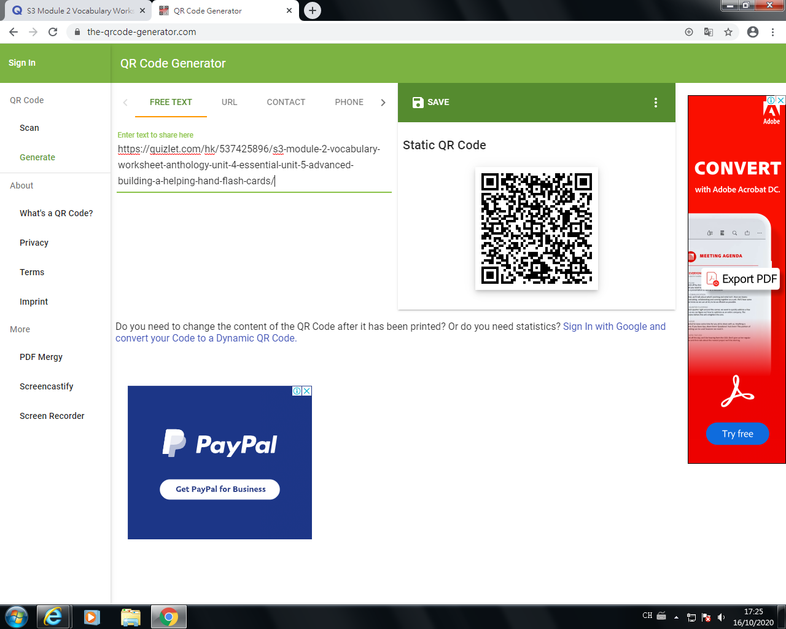

|  |  |  |  |  |
| --- | --- | --- | --- | --- |
|  |  | Line no | Part of speech | Meaning (Chinese/English/picture) |
| 1. | limbs | title | noun | 肢体 |
| 2. | taking…apart | 3 | Phrasal verb | 拆开，拆卸 |
| 3. | communities | 5 | noun | 社区 |
| 4. | mechanical | 6 | adjective | 机械性 |
| 5. | complex | 9 | adjective | 复杂的 |
| 6. | functional | 9 | adjective | 有功能的，有用途的 |
| 7. | struck | 15 | verb | 突然想到，忽然想到 |
| 8. | outgrew | 17 | verb | 生长速度超过 |
| 9. | inspired | 17 | verb | 激励; 赋予某人灵感; 启迪 |
| 10. | superior | 18 | adjective | 优良的; 更高级的 |
| 11. | customized | 18 | adjective | 定制，定做 |
| 12. | realistic | 26 | adjective | 现实的; 实际的; 明智的; 逼真的 |
| 13. | breakthrough | 31 | noun | 重大进展; 突破 |
| 14. | methods | 32 | noun | 方法 |
| 15. | affordable | 35 | adjective | 付得起的 |
| 16. | artificial | 36 | adjective | 人造的; 不自然的; 假的; 虚伪的; 不真实的 |
| 17. | currently | 38 | adverb | 现在 |
| 18. | adapt | 40 | verb | 改编; 改造; 适应 |
| 19. | compatible | 42 | adjective | 兼容的，相容的 |
| 20. | accessible | 44 | adjective | 可进入/到达/使用的 |

**Part B: Fill in the blanks**

For questions 1-10, choose the words from numbers 1-10 of the above vocabulary list.

1. Tim is a cute dog which lost one of his limbs in an accident. His left back leg was crippled.
2. I can answer simple questions very quickly. However, if the question is too complex, please give me time to think about it.
3. When I was a kid, I found it very interesting to take apart the toys and assemble them back again. I loved to find out how they were made.
4. There are many ethnic minority communities such as the Indian, Pakistani, Nepalese and Bangladeshi found in Hong Kong. We all live harmoniously.
5. Some services provided by volunteers such as repairing complex mechanical devices including air conditioner, washing machine and fan require the users to pay a price.
6. This swimming pool will be functional from next January. When it starts serving us, we don’t have to go swimming in another district.
7. Tragedy struck when her mother was killed in the street by a crazy man last night. Although it does not often happen, I hope the government will do something to prevent its happening in the future.
8. Daily life always inspired me when I was a secondary school student. I got new ideas for my writing assignments from what happened around me.
9. Your academic performance is often superior to mine. I think I need to learn your good points.
10. My parents are going to buy me new school uniforms because I outgrew them very quickly. They are happy to see that I am getting taller and taller.

For questions 11-20, choose the words from numbers 11-20 of the above vocabulary list.

1. I would like to know whether this smartphone is compatible with those learning apps. If it is not, I won’t consider buying it.
2. The shop offers customized computers. For example, we may add more RAM, increase the size of hard disk and even install required software.
3. Your study methods are effective so I would like you to share with us how you study effectively in your spare time.
4. The painting is realistic. It looks like real flowers.
5. Scientists are hoping for a breakthrough in the search for a cure for cancer. Right now, they still don’t have much progress in curing the disease.
6. As I am not very rich, I need to find somewhere affordable to stay. A subdivided flat sounds like a good option to me.
7. These flowers are artificial, so they won’t wither and fall. In other words, you can keep them as long as you like.
8. We are currently discussing school projects, so please don’t disturb us. If we don’t discuss it now, we may not have enough time to do so later.
9. The word files have been uploaded to Teams for download so any students can adapt the materials for their revision.
10. The information on the Internet is accessible to everyone. Any people can get it and use it, not necessarily for free though.

**Part C: Sentence making**

1. ____________________________________________________________________________________
2. ____________________________________________________________________________________
3. ____________________________________________________________________________________
4. ____________________________________________________________________________________
5. ____________________________________________________________________________________
6. ____________________________________________________________________________________
7. ____________________________________________________________________________________
8. ____________________________________________________________________________________
9. ____________________________________________________________________________________
10. ____________________________________________________________________________________

**Extra vocabulary**

1. **Charity events/ fundraising activities**

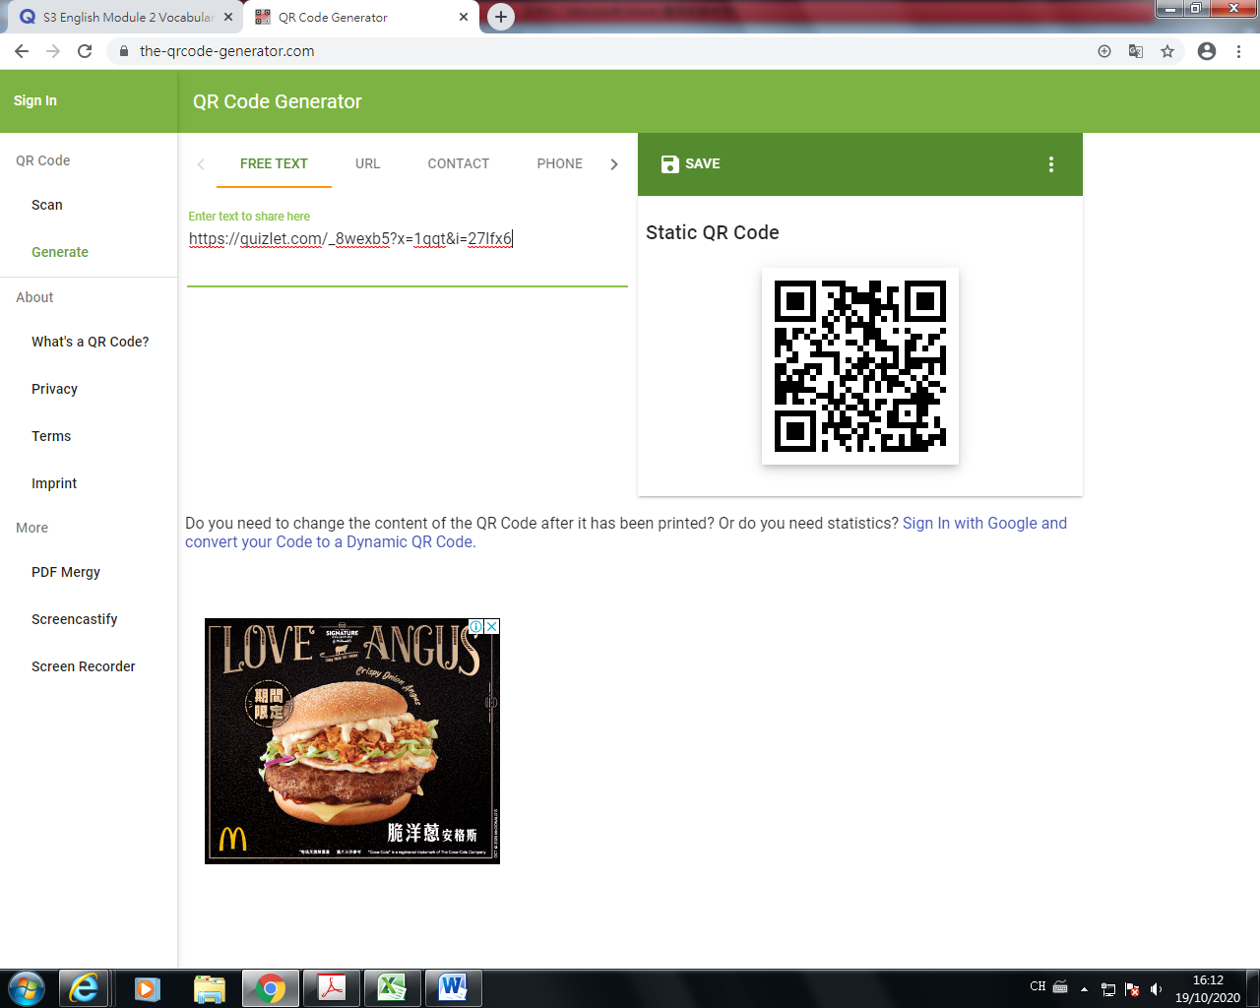

|  |  |  |  |
| --- | --- | --- | --- |
|  |  | Chinese meaning | Related vocabulary |
| 1 | auction | 拍賣 | auctioneer, bid |
| 2 | dress casual day | 便服日 | causal wear |
| 3 | jumble sale | 賣物會 | Items, second-hand |
| 4 | raffle | 抽獎 | Tickets, prizes |
| 5 | talent show | 天才表演 | Performance, performer, stage |
| 6 | cookie-selling | 曲奇銷售 | Biscuit, cake, bake |
| 7 | sponsored walk | 贊助步行 | Exercise, trail, sports shoes, walkathon |
| 8 | fete | 義賣會；慶祝會 | Celebration, drinks |
| 9 | flag day | 賣旗日 | Stickers, coins |
| 10 | fashion show | 時裝表演 | Clothes, fashionable, dress |

**Activity 1: Fill in the blanks with different fund-raising activities that you have learnt above.**

Good afternoon, Mr. Wong. We had a meeting during lunchtime to discuss different activities we could hold to raise money for the SPCA.

The craft fair was very successful last year. Many students are very talented at making handmade products. We sold a lot of soaps, keyrings, cups, bookmarks and T-shirts. This year, we could try something new since there are lots of different activities we could hold.

Alan suggested having an auction. He said that we could raise money by selling our artwork to the highest bidders. I think this is a good idea as we have many nice pieces of artwork we could sell.

Betty’s idea was cookie-selling. She likes baking and she is a member of the school’s Cookery Club so they can bake the items for us to sell. I’ve tasted her sweet treats such as chocolate cake and brownies and they were delicious. I am sure she can bake something nice for us to sell.

Debbie’s idea was a sponsored walk as we could do exercise while we were raising money. We could go to Tin Shui Wai Park or a simple trail at a country park. It sounds like a good idea as students could also invite their friends and family to enjoy the fresh air for a few hours together.

Frank said that we should have a raffle. We could sell the tickets and then have a lucky draw. The prizes would have to be quite big though to attract people to buy tickets. This might be quite expensive.

I think that we could have a jumble sale. It is easy to organise and we could work together with the PTA. We just ask all the students and teachers to bring items from their home that they don’t need anymore. We could sell items such as old clothes, second-hand shoes, used books or unwanted CDs to collect money for the SPCA.

These are all our ideas. What do you think, Mr. Wong? We could discuss them in detail later and then decide which activities to hold.

1. **Different groups of people who need help/ care in the society**

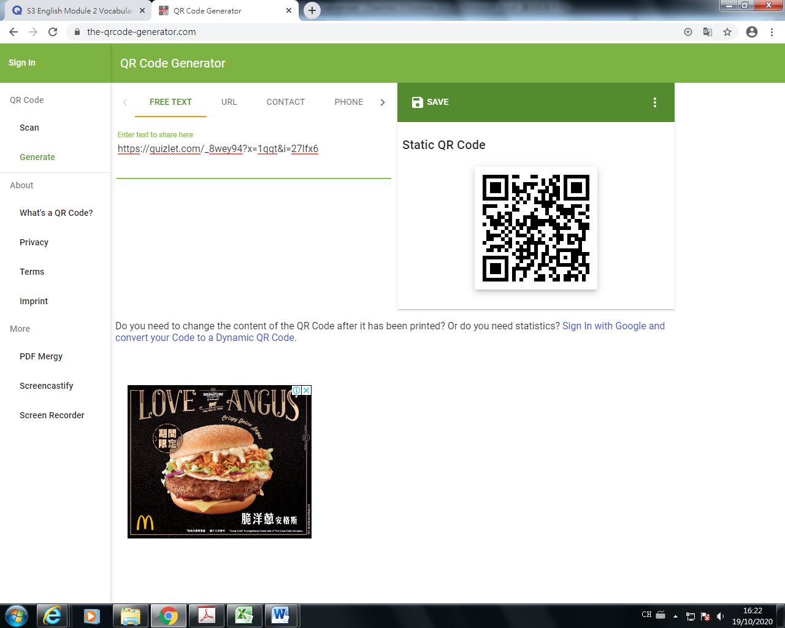

|  |  |  |  |
| --- | --- | --- | --- |
|  |  | Chinese meaning | Related vocabulary |
| 1 | the disabled  handicapped | 殘障人士 | Wheelchair, walking stick, blind, deaf |
| 2 | the elderly | 老人 | Walking stick, home for the elderly |
| 3 | the homeless | 無家可歸的人 | Park, street |
| 4 | the poor | 窮人 | No money, hungry, poverty line |
| 5 | single parent | 單親父母 | Father, mother, hardship |
| 6 | new immigrant | 新移民 | Mother tongue, daily communication |

**Activity 2:** **Answer the following question in complete sentences.**

1. **If you had enough money to help one group of people mentioned in the table above, who would you help? Choose one group of them and give a reason.**

______________________________________________________________________________________________________________________________________________________________________________

______________________________________________________________________________________________________________________________________________________________________________

1. **Are there any other groups of people that are not mentioned in the table above but are in (desperate) need of our help and care in the society? Explore one group of them and give a reason.**

______________________________________________________________________________________________________________________________________________________________________________

______________________________________________________________________________________________________________________________________________________________________________

1. **Names of charitable organizations**

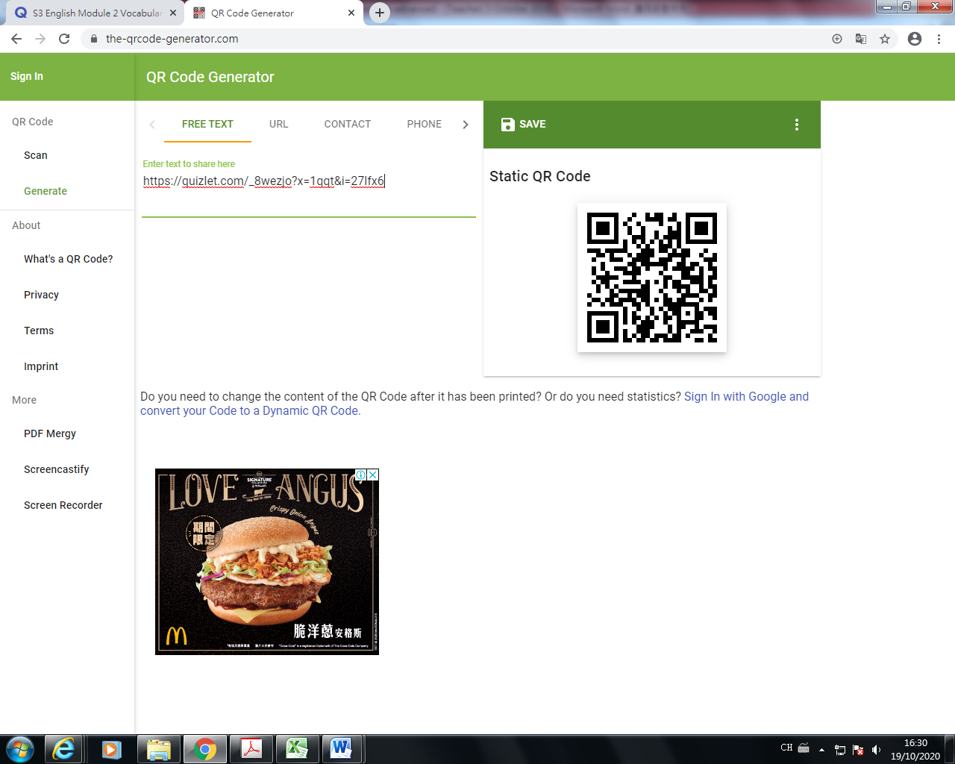

|  |  |  |  |
| --- | --- | --- | --- |
|  |  | Chinese meaning | Related vocabulary |
| 1 | The Community Chest of Hong Kong | 香港公益金 | Grants, community projects |
| 2 | Hong Kong Red Cross | 香港红十字会 | Blood transfusion |
| 3 | Hok Yau Club | 學友社 | Support, guidance, the youths |
| 4 | Tung Wah Group of Hospitals | 东华三院 | Education, community services |
| 5 | St. James Settlement | 聖雅各福群會 | Family and counselling |
| 6 | Po Leung Kuk | 保良局 | Orphaned children |
| 7 | Caritas Hong Kong | 香港明爱 | Catholic |
| 8 | Hong Kong Society for the Protection of Children (HKSPC) | 香港保护儿童协会 | Cares for children |

**Activity 3: Read the details of the following charitable organizations.**

|  |  |
| --- | --- |
| **Name and details of the charitable organisations:** | **Logo:** |
| 1. **The Community Chest of Hong Kong** was established in Hong Kong on 8 November 1968. The Community Chest provides grants and funding to a wide range of community projects. | community chest hk logo的圖片搜尋結果 |
| 1. **Hong Kong Red Cross** was established officially on 12 July 1950 as a branch of the British Red Cross Society in Hong Kong. Hong Kong Red Cross known for blood transfusion in Hong Kong, which runs under the Hospital Authority. | hk red cross的圖片搜尋結果 |
| 1. **Hok Yau Club** is an independent and non-profit non-governmental organisation (NGO) in Hong Kong. Its aim is to provide support and guidance to students as well as to organise activities for youths. | hok yau club的圖片搜尋結果 |
| 1. **Tung Wah Group of Hospitals**, with a history dating back to 1870, is the oldest and largest charitable organisation in Hong Kong. It provides education and community services through 194 service centres spread across Hong Kong. | tung wah group of hospitals的圖片搜尋結果 |
| 1. **St. James' Settlement**  is also known as SJS, a non-governmental charitable organisation in Hong Kong with more than 60 years of history. It provides care, family and counselling, rehabilitation, youth and community centre services. | st james settlement的圖片搜尋結果 |
| 1. **Po Leung Kuk**, founded as the Society for the Protection of Women and Children, is a charitable organisation in Hong Kong that provides support for orphaned children, education and other services. | po leung kuk的圖片搜尋結果 |
| 1. **Caritas Hong Kong** is a member of Caritas Internationalis, founded by the Catholic Diocese of Hong Kong in July 1953. It started with relief and rehabilitation services to the poor and the distressed after the Second World War. | caritas hk的圖片搜尋結果 |
| 1. **Hong Kong Society for the Protection of Children (HKSPC)** relies on direct donations and fundraising among the community. In 27 centres across Hong Kong, HKSPC cares for children from newborn to 16-year-olds. | 相關圖片 |

**Anthology Unit 4: Urban development**

**Part A: Vocabulary list**

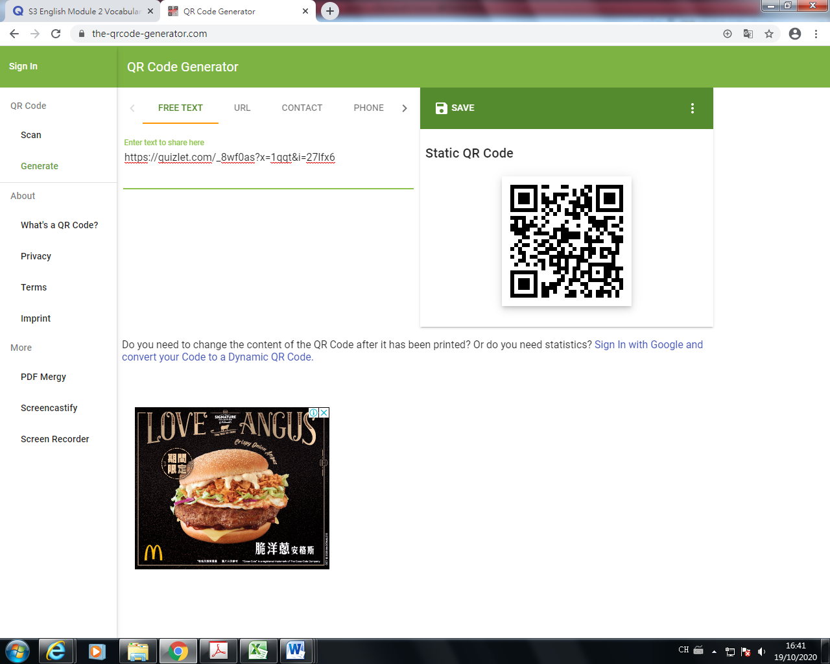

|  |  |  |  |  |
| --- | --- | --- | --- | --- |
|  |  | Line no | Part of speech | Meaning (Chinese/English/picture) |
| 1. | extend | title | verb | 延長; 擴展 |
| 2. | moderator | 1 | noun | （討論、會議等的）主持人 |
| 3. | …in favor of… | 3 | phrase | 贊成[支持]（某人或某事物） |
| 4. | booming | 7 | verb | 急速發展的 |
| 5. | subdivided flats | 9 | Noun phrase | 細分的公寓 |
| 6. | nano flats | 10 | Noun phrase | 納米公寓 |
| 7. | crisis | 14 | noun | 危機 |
| 8. | property | 19 | noun | 財產; 房地產 |
| 9. | opponent | 24 | noun | 對手; 反對者 |
| 10. | persuade | 24 | verb | 勸說; 使信服 |
| 11. | disappear | 26 | verb | 消失; 失蹤; 滅絕 |
| 12. | zones | 32 | noun | （劃分出來的）地區 |
| 13. | adopted | 32 | Verb/ adjective | 被採用的 |
| 14. | conservation | 35 | noun | 保護; 節約 |
| 15. | opposition | 39 | noun | (強烈的）反對，敵對 |
| 16. | frankly | 42 | adverb | 直率地（說），坦誠地; 真誠地; 坦白地 |
| 17. | skyscrapers | 46 | noun | 摩天大樓 |
| 18. | precious | 47 | adjective | 寶貴的; 珍奇的 |
| 19. | grant | 52 | verb | 授予 |
| 20. | temporary | 52 | adjective | 短暫的 |

**Part B: Fill in the blanks**

For questions 1-10, choose the words from numbers 1-10 of the above vocabulary list.

1. An opponent is a person who disagrees with something and speaks against it or tries to change it. For example, we can often see many people who hold different opinions on and/or disagree with the government policy.
2. To extend the period of wearing a face mask is a good thing to some people because they think it is a kind of effective protection.
3. Many controversial cases are eventually brought up to courts so that judges can be the moderator to settle the dispute.
4. My teacher spoke in favor of studying in China. He listed many advantages of it.
5. Many people are only able to afford nano flats because the housing prices are too expensive in Hong Kong. They can only buy very small areas to live.
6. When living in subdivided flats, you may expect to share a kitchen or even a toilet with other flat mates. However, if you can pay more, you may have a tiny but independent toilet to use.
7. The pandemic is a crisis for everyone in the world. We all will be in danger if we don’t work together.
8. Many poor families cannot afford the high property prices and end up living in subdivided flats with very limited space.
9. English teachers always persuade students to check up dictionary. They hope the students will listen to them and do as they said because they think the method is useful for learning.
10. The food delivery service is booming, since many people order food online.

For questions 11-20, choose the words from numbers 11-20 of the above vocabulary list.

1. Even though the government has done a lot to persuade people redevelopment is important for the economy and hopes they will agree with it, there is still strong opposition since some activists believe development shouldn’t outweigh the protection of our history.
2. Land here in Hong Kong is so preciousthat we have to think very carefully about the land use in our urban planning. For example, we have particularly kept some zones for ‘green spaces’ while we focus on building more houses in the areas.
3. Before your suggestions are adopted, I think I need to discuss them with my management first.
4. In Hong Kong, we gave up a lot for building skyscrapers such as tearing down the old buildings. Some of them are historical buildings. Therefore, some critics say we should do more on conservation.
5. Frankly, I like this laptop, but I don’t have enough money at the moment. I need to go home and ask my parents for money tonight.
6. There are so many tall buildings in Hong Kong. These skyscrapers form a very beautiful skyline!
7. The snow will soon disappear when the warm weather comes. Therefore, you should treasure this moment to enjoy the fun of playing snow with your friends.
8. Children are precious to parents. The parents are willing to give up a lot for them, including money, time and even their lives.
9. If my parents are willing to grant my request on buying a new computer, I believe that I will be more efficient when doing homework.
10. A temporary solution only lasts for a short period of time. Afterwards, we will have to work together and come up with another solution again. Let’s see whether we can have a permanent solution for this problem.

**Part C: Sentence making**

1. ___________________________________________________________________________________
2. ___________________________________________________________________________________
3. ___________________________________________________________________________________
4. ___________________________________________________________________________________
5. ___________________________________________________________________________________
6. ___________________________________________________________________________________
7. ___________________________________________________________________________________
8. ___________________________________________________________________________________
9. ___________________________________________________________________________________
10. ___________________________________________________________________________________

**Extra vocabulary**

1. **Social issues**

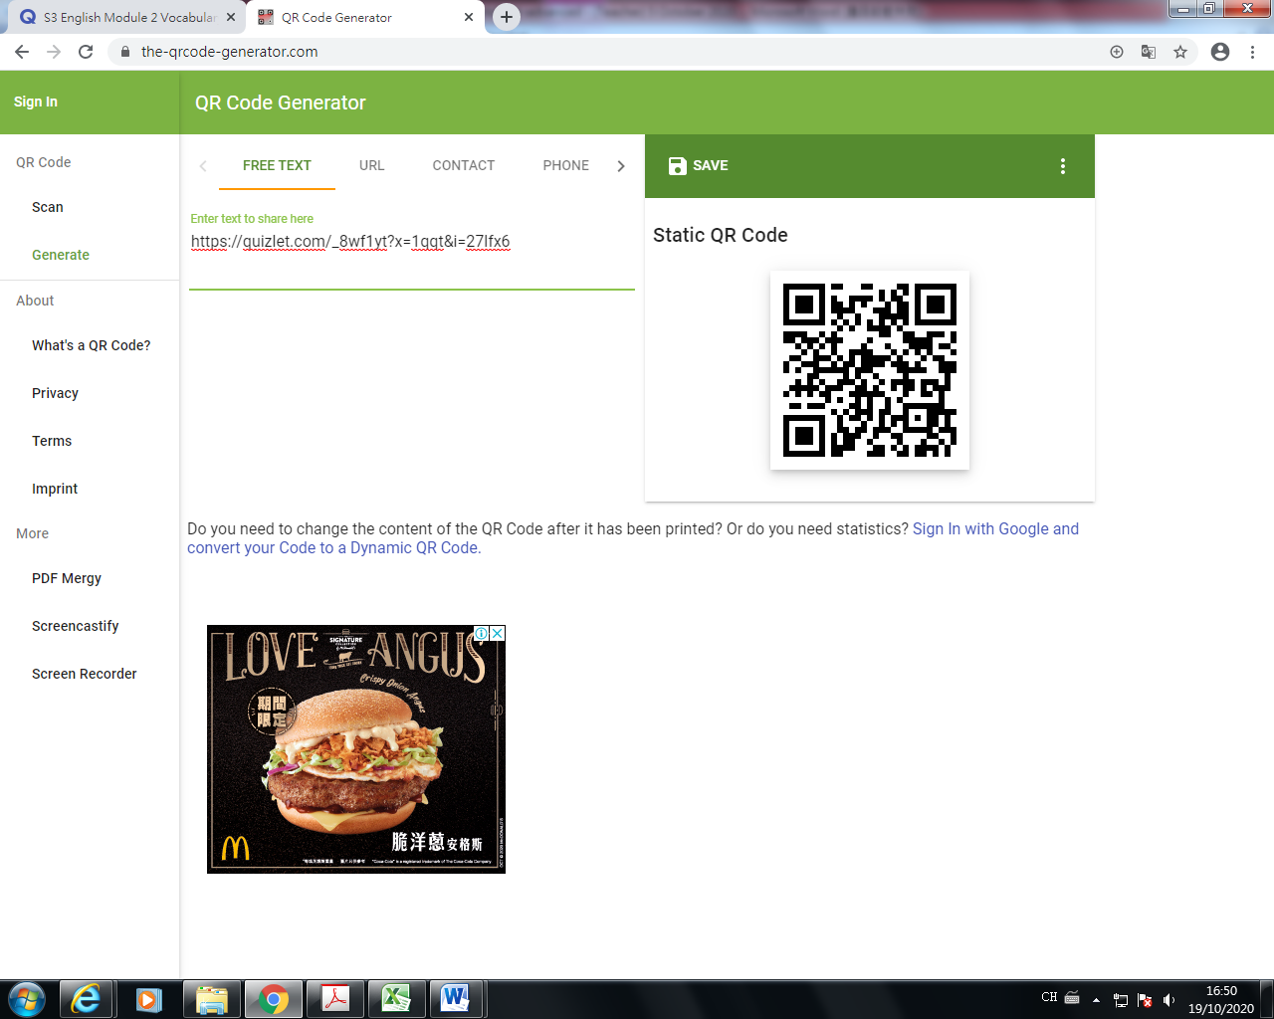

|  |  |  |  |
| --- | --- | --- | --- |
|  |  | Chinese meaning | Related vocabulary |
| 1 | animal abuse | 虐待动物 | Stray dogs, cats |
| 2 | child abuse | 虐待儿童 | Bruise, victims |
| 3 | drug addiction | 吸毒成瘾 | Cocaine, ecstasy |
| 4 | gambling addiction | 赌博成瘾 | Macau, casino |
| 5 | homelessness | 无家可归 | MacDonald’s, park |
| 6 | Internet addiction | 网络成瘾 | Online games |
| 7 | poverty | 贫穷 | No money, hunger |
| 8 | bullying | 欺凌 | Crying, bleeding |
| 9 | divorce | 离婚 | Single parent |
| 10 | drink driving | 酒后驾驶 | Death, traffic accidents |
| 11 | sex discrimination | 性别歧视 | Workplace, job applicants |
| 12 | suicide | 自杀 | Roof, jump |

**Activity 4: Match the social issues mentioned in the table above with the following descriptions.**

|  |  |  |
| --- | --- | --- |
| web addictionçåçæå°çµæ  Some people cannot stay away from their computers or smartphones because they always need to be online. | ç¸éåç  Some people treat men or women differently or unfairly just because they are either male or female. | gambling addictionçåçæå°çµæ  Some people spend all their money on betting. They may lose all their money and borrow more, but lose that too. |
| 1. **Internet addiction** | 2. **sex discrimination** | 3. **gambling addiction** |
| homelessnessçåçæå°çµæ  Some people have nowhere to live. They don’t have a house or flat. They have to sleep on the streets or in public areas. | divorceçåçæå°çµæ  Some married couples find that they need to or want to separate. They need to sign papers with their lawyers. | animal abuseçåçæå°çµæ  Some people mistreat their pets or other animals. For example, they may kick them or hit them or not give them any food. |
| 4. **homelessness** | 5. **divorce** | 6. **animal abuse** |

**Answer the following question in complete sentences.**

**What do you think is the most serious social issue in Hong Kong? Choose one and give a reason.**

______________________________________________________________________________________________________________________________________________________________________________

______________________________________________________________________________________________________________________________________________________________________________

1. **Types of volunteer workers**

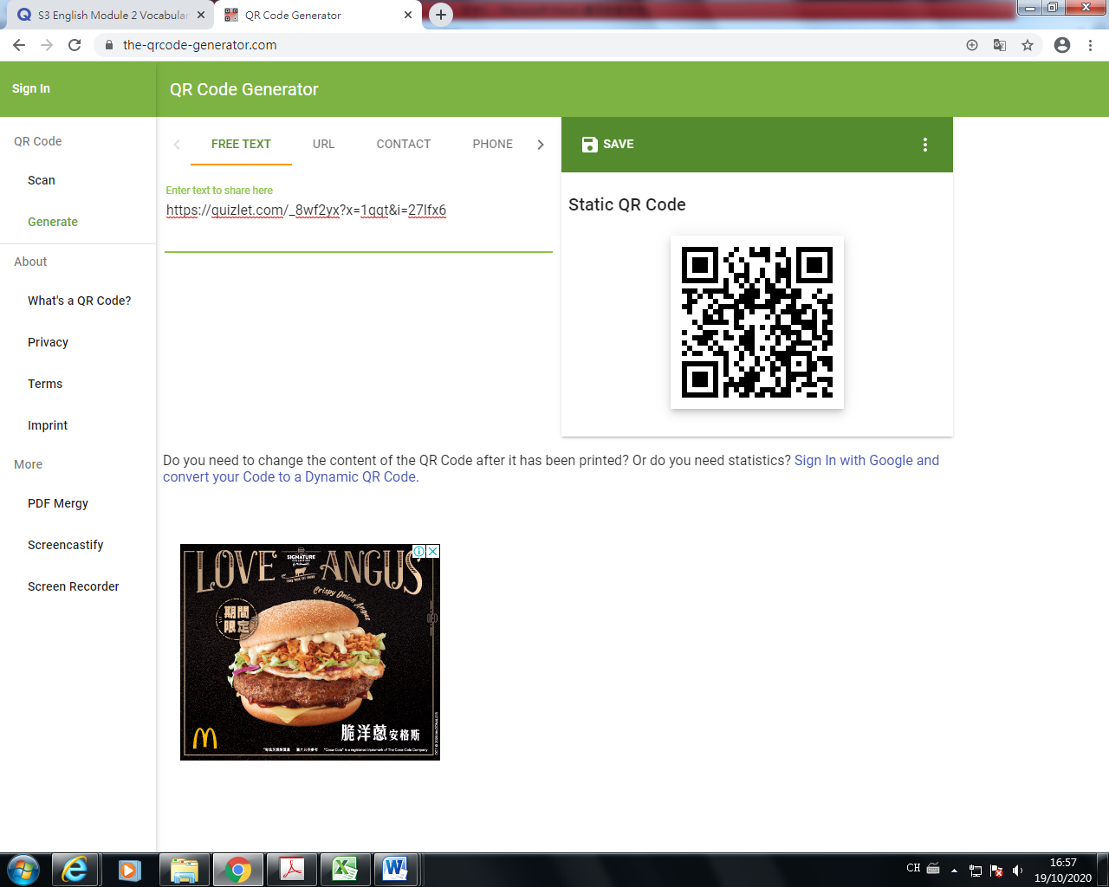

|  |  |  |  |
| --- | --- | --- | --- |
|  |  | Chinese meaning | Related vocabulary |
| 1 | caregiver | 看顾者 | The elderly, people in need |
| 2 | coach | 教练 | Life coach, guidance |
| 3 | dog walker | 犬行者 | Walking stick, the blind, the elderly |
| 4 | tutor | 导师 | Different subjects, answer queries, explain concepts |
| 5 | flying doctor | 飞行医生 | Medical aid |
| 6 | hotline counsellor | 热线辅导 | Unhappiness |

**Activity 5: The following three volunteers describe what they do in their volunteer work. Match the jobs with the types of volunteer work mentioned in the table above. Write your answers in the spaces.**

|  |  |
| --- | --- |
| dog walking clipartçåçæå°çµæ | hotline answer clipartçåçæå°çµæ |
| May: I am a dog  walker.  I love animals. I enjoy looking after pets but I cannot keep one at home so I volunteer to spend some time with other people’s pets. | Anna: I am a hotline counsellor.  I answer phone calls and talk to people who need someone to listen to them talk about their problems. I try to give them useful and helpful advice. |

1. **Benefits of doing voluntary work/ benefits of being a volunteer**

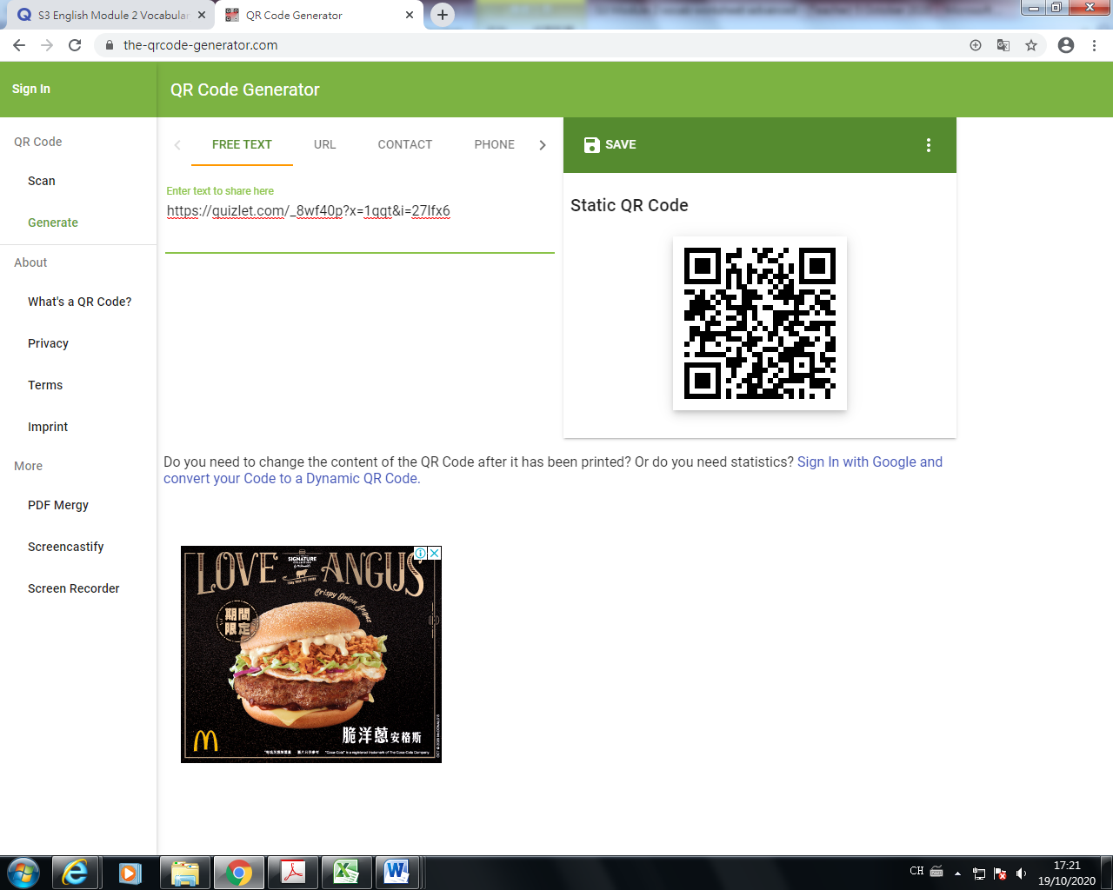

|  |  |  |  |
| --- | --- | --- | --- |
|  |  | Chinese meaning | Related vocabulary |
| 1 | muster up courage | 鼓起勇气 | Don’t be disappointed |
| 2 | gain respect | 获得尊重 | Human dignity |
| 3 | motivation | 动机 | Accomplish a task |
| 4 | commitment | 承诺 | From the beginning till the end |
| 5 | a sense of achievement | 成就感 | A distinction, satisfactory completion of a project |
| 6 | ends loneliness | 结束寂寞 | A soulmate, social occasions |
| 7 | increases socializing | 增加社交 | Party, new friends |
| 8 | develops emotional stability | 发展情绪稳定 | Calm down, take a deep breath |
| 9 | improves self-esteem | 提高自尊心 | Gain respect |
| 10 | improves school and college experience | 提高学校和大学的经验 | Take part in various extra-curricular activities |
| 11 | provides better job prospects | 提供更好的工作前景 | Acquire work experience |

**Activity 6:**

**Task 1**

**Think about the factors that are most important to you when you think about doing voluntary work. What are the top three most important factors for you?**

|  |  |
| --- | --- |
| 1st |  |
| 2nd |  |
| 3rd |  |

**Compare your answers with a partner.**

**Task 2 - Mini survey {OPTIONAL}**

**You are going to ask four of your classmates questions about voluntary work. Try to get as much information as possible and make notes.**

|  |  |  |  |  |
| --- | --- | --- | --- | --- |
| **Names** |  |  |  |  |
| **Have you ever done any voluntary work?** |  |  |  |  |
| **If so, what did you do?** |  |  |  |  |
| **If not, would you like to and why?** |  |  |  |  |

**Now tell the class what you found out.**

**END**